FINAL TESTING DOCUMENTATION

TEAM: NASA RASC & 21Spr3
Table 1 below shows the teams engineering requirements and what the testing results yielded. Further detail will be shown in the report below. Testing results highlighted in green show the value has met the goal, and those highlighted in red show that the testing result has not met the goal.
Table 1: Requirements and Testing Results
Engineering Requirements | Units | Target Value | Testing Results
Budget | $/yr | 1 Billion | 4,181,263,718.56
# Of Livable Days | # | 30 | >30
Radiation Reduction | % | 60 | 84.4
Heat Rejection | kW | 30 | 33.5
Livable Space | $$m^{3}$$ | 50 | 43.5
Dry Mass Limit | kg | 6000 | 8500
Whipple Shield Impact Absorption | J | 259.2 | 7 x 10⁻⁷
Inside Air Pressure | kPa | 101.325 | Pass @ FOS:31.4

The following report details the individual engineering requirements and what testing was conducted to prove that the criteria have been met.
- Budget
Our budget for this project consists of 1 billion dollars per year up until the year of 2028. We have split our funds to be allocated to four major areas: Materials & Manufacturing, Quality Assurance & Testing, Labor Force, and Insurance. We felt that 40%, 9%, and 10% would go to Quality Assurance & Testing, Labor Force, and Insurance respectively because it is difficult to say exactly how much we would be spending on these categories since our project is very analytical. Unfortunately, our total cost per year is (4,181,263,718.56) which is way over budget in terms of how much our habitat would cost to manufacture and assemble for launch per year. This is mainly due to our part count and the materials we chose (i.e., Carbon Fiber and Aluminum 6061-T6). If we were to continue this project our goal would be to reduce the overall size (and possibly redesign the entire habitat) with the hope that it would reduce the Materials & Manufacturing cost. It is also worth noting that the Quality Assurance & Testing, Labor Force, and Insurance would vary greatly due to unforeseen circumstances that can arise during the testing and quality assurance phases.
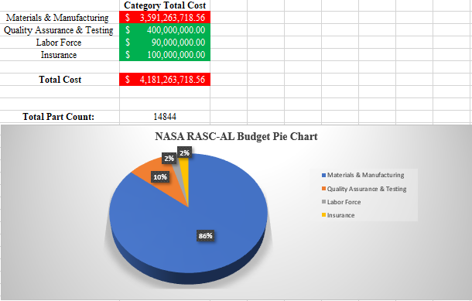
Figure 1: Budget

- Number of Livable Days:
Based on the design that we have created, when considering the whipple shield protecting the habitat, all the security measurements of assessing and deescalating tragedies on board and the oxygen and water refinery systems, the number of livable days on board the Lunar Habitat far surpasses the value of 30 days. The whipple shield has simple design that will protect the astronauts from numerous asteroids colliding. The design will also integrate a simple way of switching out the shields that have been punctured in order to bring the design back to 100%.
The ECLSS has an integration from the ISS which has astronauts living in it year-round. The design of the water refinery system has an efficiency of 97% which would allow the humans to survive through only one shipment of water for up to 4 months if the efficiency began to degrade. The oxygen refinery system on the ECLSS has yet to fail NASA, therefore allowing us to assume that we will not have an issue with the oxygen system degrading. The target of a habitat sustainable for 30 days for 2 astronauts has been far surpassed in every department throughout the designs on board.

- Radiation Reduction:
An analytical approach was taken to confirm the amount of radiation reduction would occur with the multi-layer insulation (MLI) shield present. The Stephan-Boltzmann law was used to determine the temperature of the outside of the habitat due to the radiation flux from the sun. This is shown in equation 1 below.
$T_{1}= {\left(\frac{Φ}{σ}\right)}^{1/4}$ (1)

Where Φ is the radiation flux from the sun, approximately 1422 W/$m^{2}K$ and σ is the Boltzmann constant. $T_{1}$ was determined to be 125°C. Equation 13.28 from Fundamentals of Heat and Mass Transfer 8th Edition [1], will be used to determine how much electromagnetic radiation energy the astronauts would see inside the habitat, and determine how much the MLI shield reduces the flux by. Equation 13.28 is shown below.
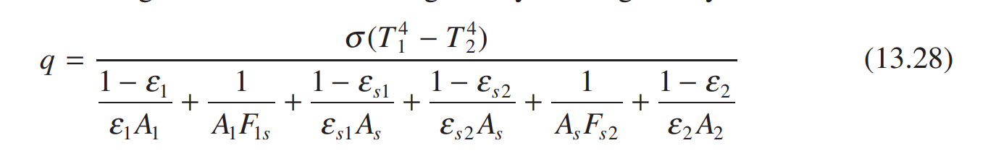
This was adopted to the nomenclature shown in figure 2 below. Figure 2 is a picture of the MLI shield and thermal radiosity network that represents the picture.
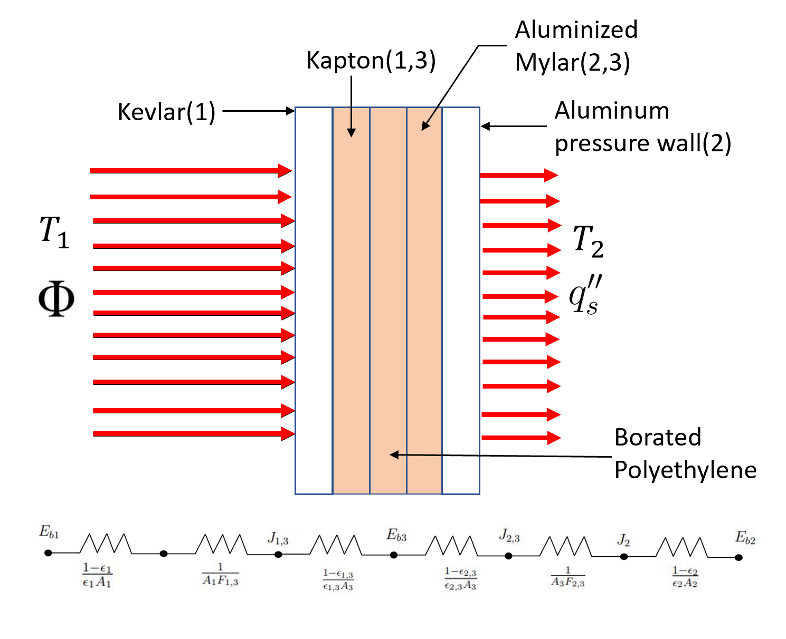
Figure 2: Multi-Layer Insulation (MLI) Diagram and Thermal Radiosity Network
Several assumptions were made to simplify equation 13.28 into the equations shown below. These assumptions are as follows:
- $A_{1}= A_{2}= A_{3}=A$
- $F_{1,2}= F_{2,3}=1$
- Surfaces are Diffuse and Gray
- Uniform Incoming Radiation Flux
- Steady State
The radiation flux with and without the shield was calculated using the process shown below. The “s” subscript represents the radiation flux with the shield.
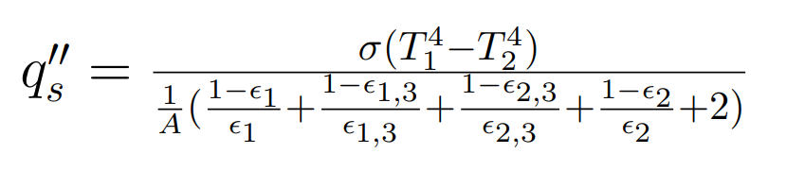 (2)
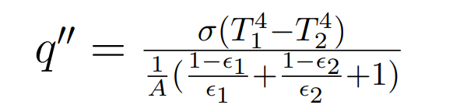 (3)
It was determined that the astronauts would see approximately 15.4 $W/m^{2}$ of radiation flux which is an 84.4% reduction from the flux calculated without the shield. This fulfilled our radiation reduction engineering requirement benchmarked from the ISS which was about 60% [2].
- Heat Rejection:
The life support systems necessary to the survival of the astronauts put off an excessive amount of heat within the habitat that will not leave due to the MLI shield which also keeps heat in. For this reason, it is necessary to adapt a climate control system that can pull heat directly from the life support systems and eject it into space via radiation. The International Space Station uses a similar method, which was used as inspiration for this design. Figure 2 below shows a diagram created to better understand the ATCS (Active Thermal Control System) proposed.
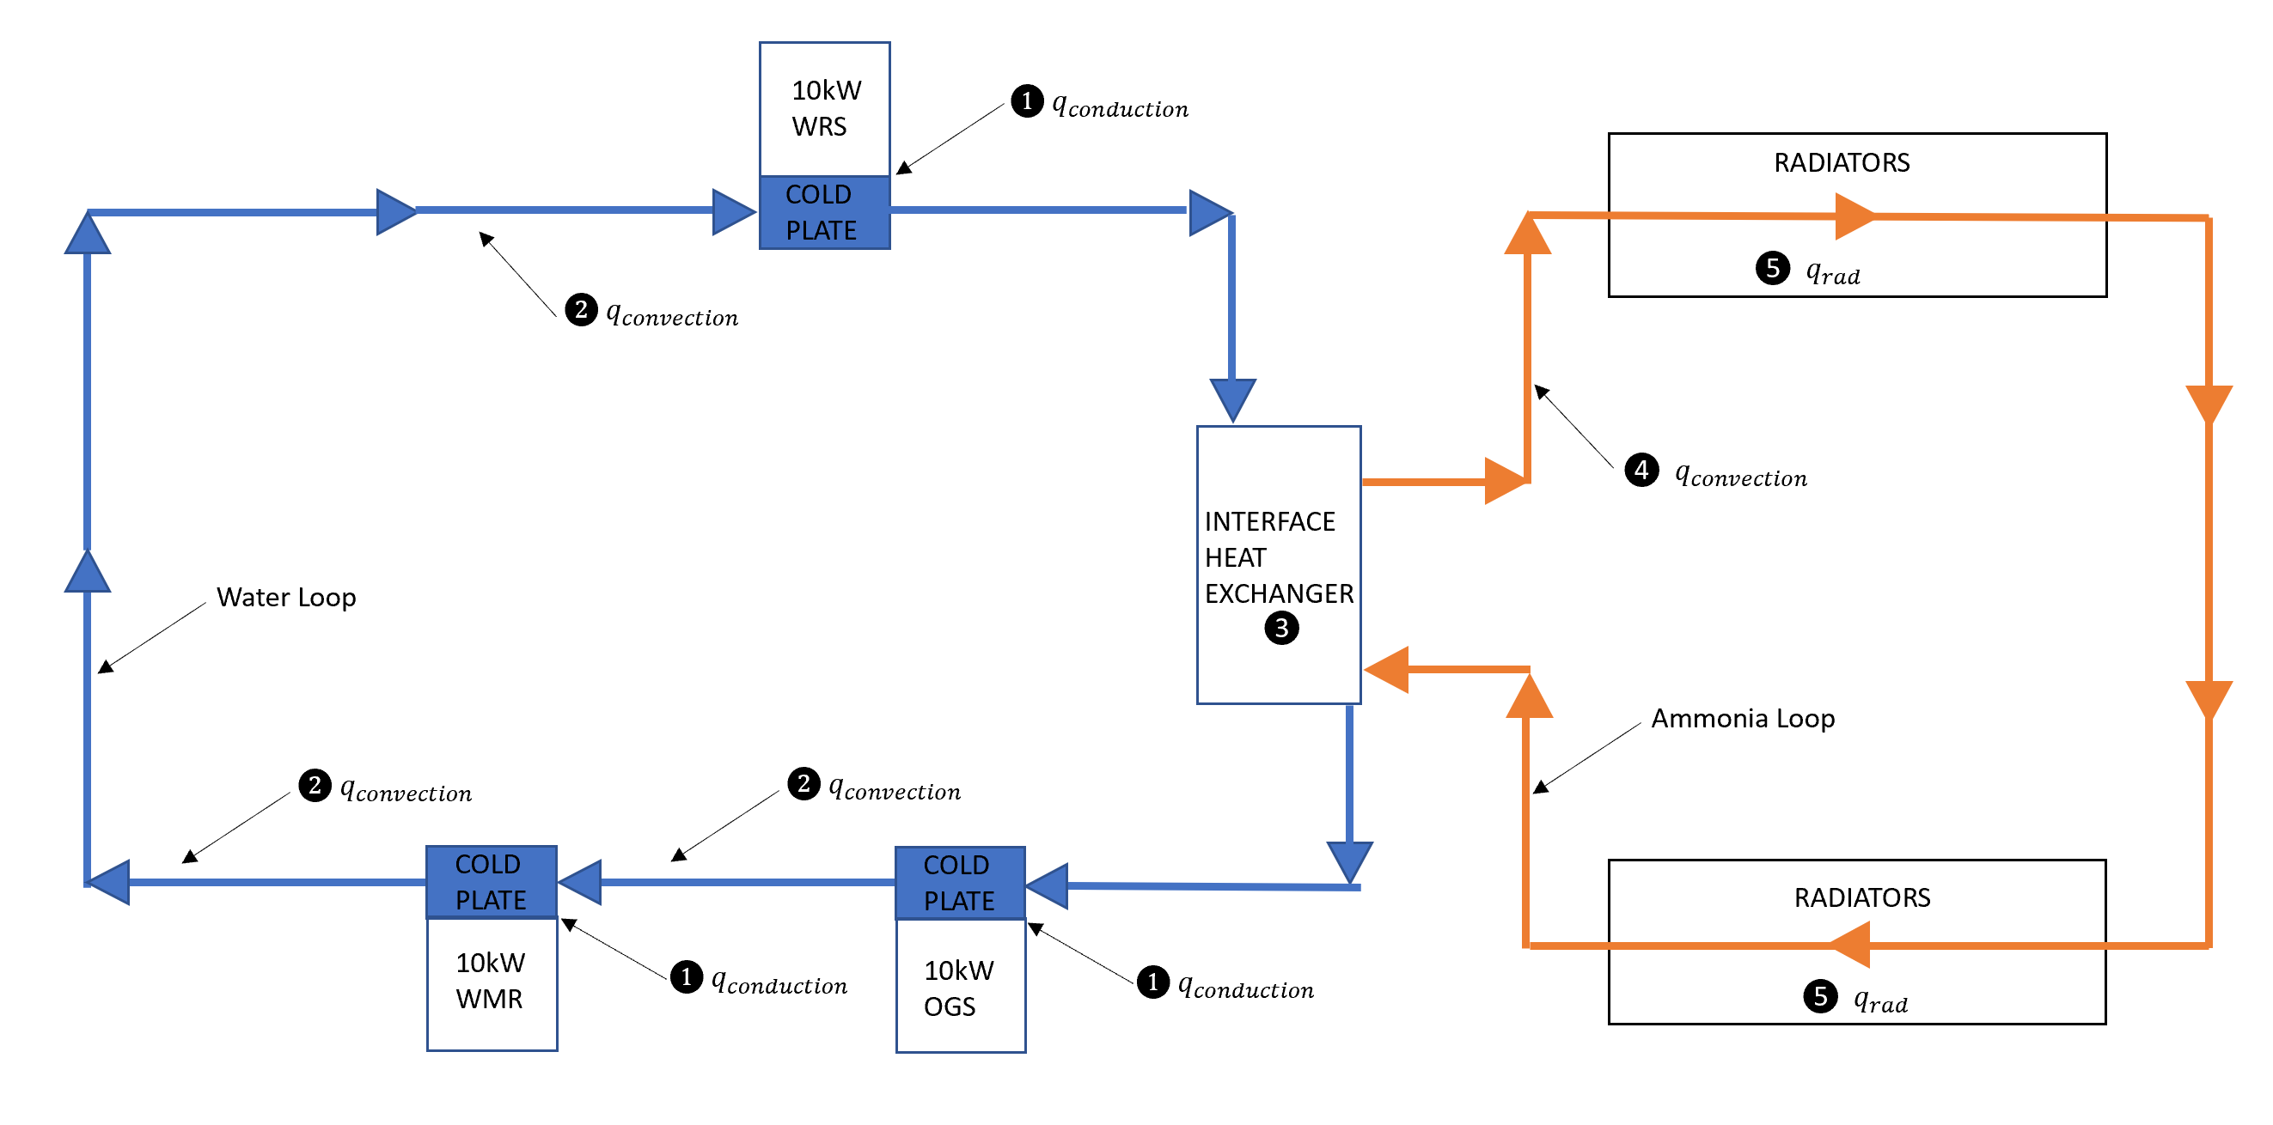
Figure 2: Active Thermal Control System
Equation 4 was derived from the first law of thermodynamics to determine the amount of heat that could be exchanged through the heat exchanger. Equation 5 was adopted to determine the amount of radiators required to radiate off all of the heat exchanged from the interface heat exchanger.
$\dot{Q}= {\dot{m}}_{12}C_{p}(T_{2}-T_{1})$ (4)
$q_{rad}= A_{rad}nεσ(T_{rad}^{4}-T_{space}^{4}$) (5)
These equations resulted in a heat exchange rate of 33.5kW and 16 4m x 1m radiators necessary to radiate all the heat. This clearly meets the requirement of 30kW which was determined from downscaling heat generation values from the ISS [3].
- Livable Space (Keith):
Due to healthy psychological human factors, the livable space inside the habitat needed to meet approximately 50m³. The initial habitat was built for 61.26m³ however after accounting for the floorboard, support systems and the airlock area, the habitable area came out to 42.41m³. The figure below describes the cross section of the final habitat.
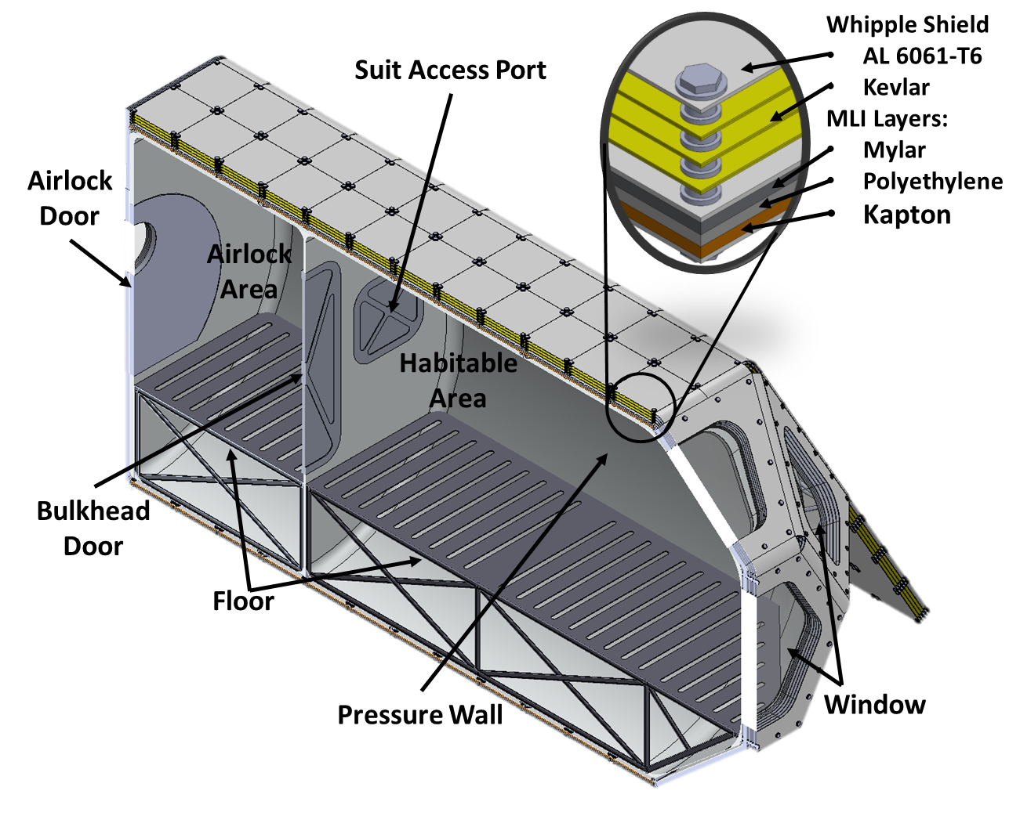
Figure 6: Final Cross Section of the Lunar Habitat
More analysis is needed to increase the habitable area back to 50m3 potentially taking the space from the space under floorboard and reducing the airlock area.
- Mass Limit Requirements (Keith):
The current dry mass including just the Whipple Shield, Multi-Layer Insulation, Bone Structure, and pressure wall comes out to 8500kg. This is 2500kg higher than the requirement of 6000Kg. However, we believe this is essential for successful Artemis lunar mission. Further analysis could be done to replace some of the materials to carbon fiber however, a thermal analysis should be conducted while accounting for internal and external pressures.

- Whipple Shield Energy Reduction (JELANI):
Our Whipple Shield is a simple design that is benchmarked off the I.S.S to protect our habitat from micrometeorites. To analytically simulate the energy reduction and meet our requirement of absorbing less than 259 (J) of energy a model was created within MATLAB using equations (6,7,8). Equation (6) aids in finding the amount of time it takes for a micrometeorite to travel through the any layer of the Whipple shield. Following that we have equation (7) which solves for the final velocity of the micrometeorite after the impact by assuming that the impact will be inelastic due to energy loss. Lastly, we have the basic kinetic energy equation (8) which solves the amount of kinetic energy based on the final velocity of the micrometeorite after the impact. As you can see this process was repeated for both the front and rear bumper and if you refer to the change in magnitude of kinetic energy between the front (Figure x.) and rear bumper (Figure x.) you can see that the energy absorbed is well below 259 (J).

$\int_{t_{i}}^{t_{f}}{v dt}=\int_{x_{i}}^{x_{f}}{dx}$ (6)
$v_{f}=\frac{m_{1}v_{1_{i}}+m_{2}v_{2_{i}}}{m_{1}+m_{2}}$ (7)
$K.E. = \frac{1}{2}m{v_{f}}^{2}$ (8)

Figure 7: Front Bumper Energy Absorption Range
Figure 8: Rear Bumper Energy Absorption Range
- Whipple Shield Solid Works Simulation:
The Whipple test was performed using a 5mm X 5mm x 2.5mm projectile. This size was chosen as a smaller size projectile would not mesh. The test was conducted for 5000N across the surface of the projectile. The Whipple shield handled the test well which was backed up by the analytical analysis above. A new test fixture was generated using the specific materials that composed of the Whipple shield including Kevlar 49 material properties for the middle plates. All other materials including the washers were modeled with 6061-T6 Aluminum. The figure below shows the mesh model of the Whipple shield.
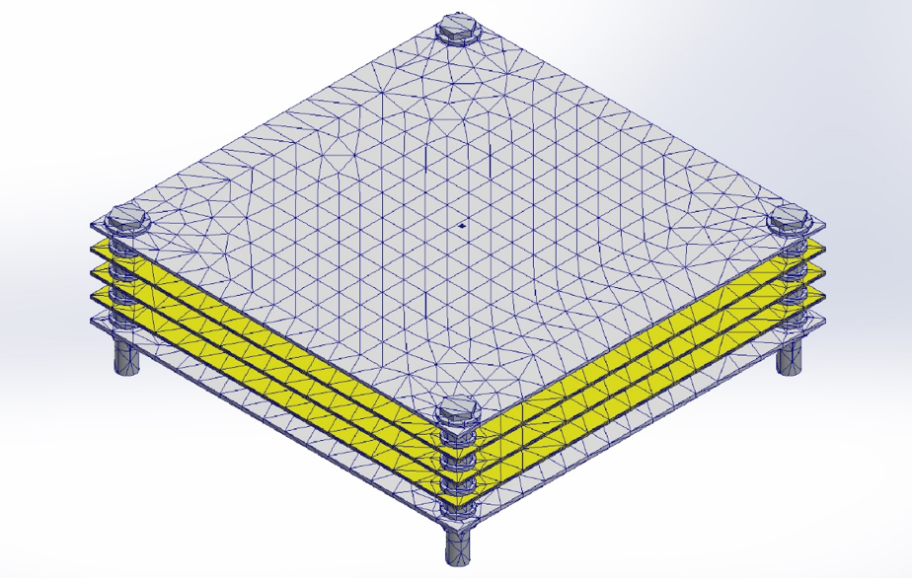
Figure 9: Whipple Shield Mesh

Further refinement was done to obtain fine mesh around the projectile and coarse for the plates to simplify the study.
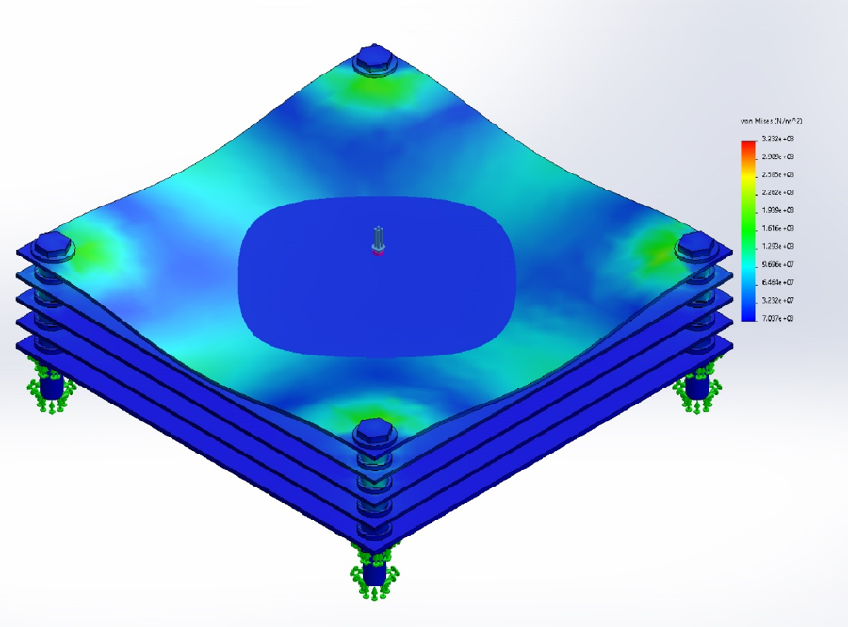
Figure 10: Von Mises Stress Results
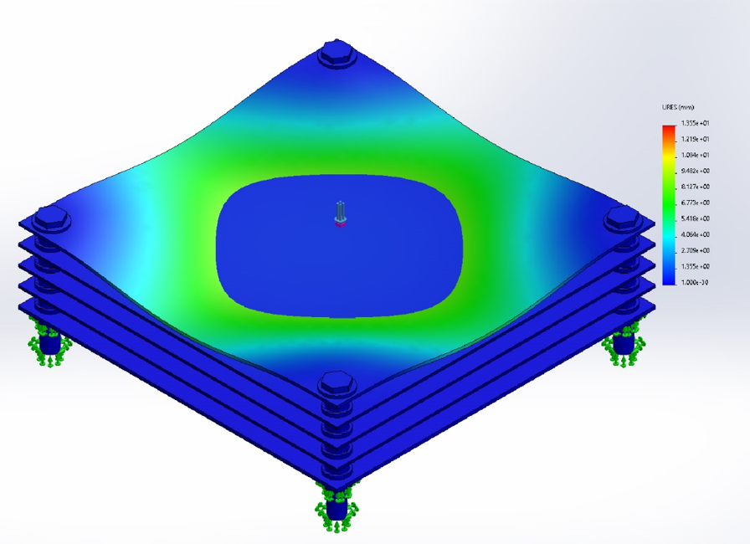
Figure 11: Displacement Results
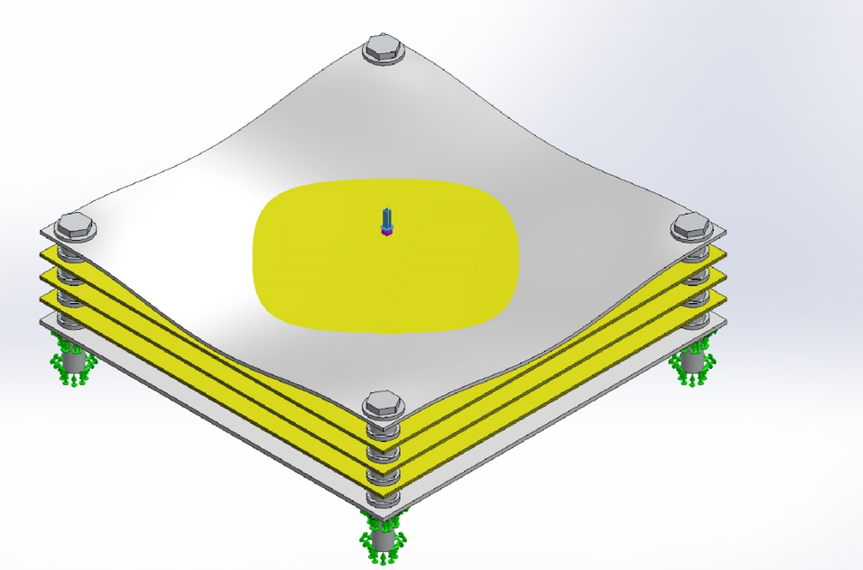
Figure 12: Total Displacement Result

The results are from the study showed that the maximum deformation is 3.691mm, maximum stress of 323.2MPa and maximum displacement of 13.5mm which is acceptable for the force tested for. This is in line with the analytical analysis and does predicts that the energy absorption is indeed a success. Thus, based on the results, the test was a pass. However, a non-linear simulation with a smaller projectile might be necessary to closely model the impact at an angle.
- Inside Air Pressure (KEITH):
Two studies were conducted for the pressure wall analysis. Initially, a simulation was run assuming that the pressure wall thickness is at 25.4mm for 6061 T6 Aluminum. The results of the study are provided below.
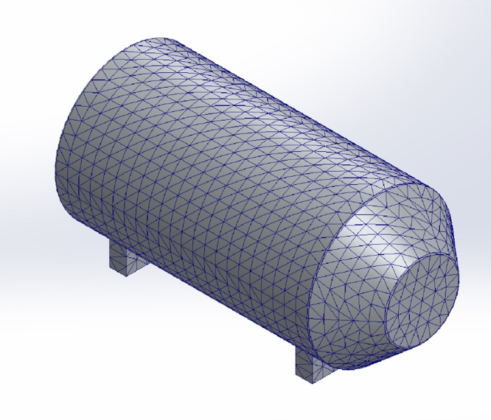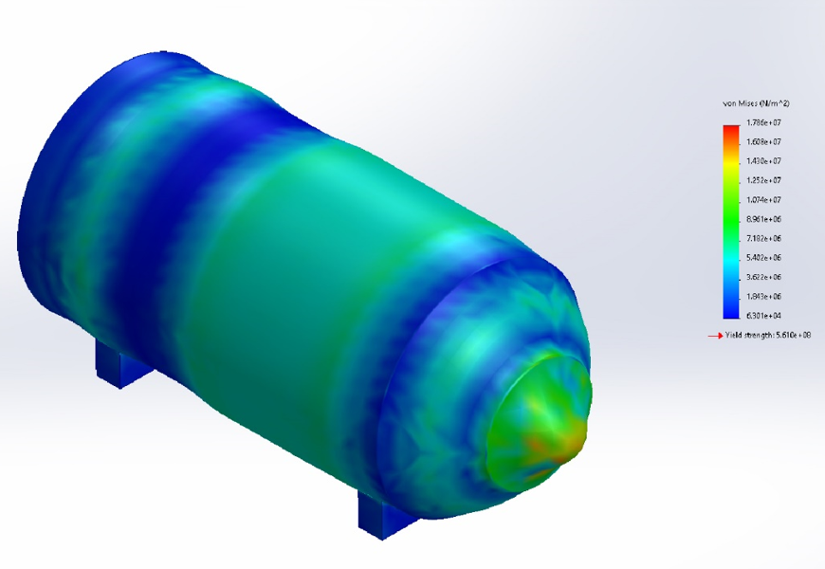
Figure 12: Mesh generation and Von Mises Stress Results
As shown above, support structures were added to the model and the test was conducted for atmospheric pressure of 101,300Pa. The study resulted in a Max Stress at Nose of 17.86MPa, max displacement of 2.17mm and a factor of safety of 31.4. The maximum stress is at the nose will be addressed as the nose will be replaced with window that will be able to handle the extreme pressure concentrations.
Once the thickness of the pressure was determined to be accurate, analytical calculations were performed to account for the desired weld quality. The formula used for the analysis is provided below.
$t=\frac{P*D}{2((S*E*W)+(P*Y))}$ (9)
Where,
T = Wall Thickness
P = Maximum Internal Pressure
D = Outer Diameter
S = Allowable Stress
E = Weld Quality Factor (Fusion Welded Pipe)
W = Weld Joint Strength
Reduction Factor (0.5)
Y = Wall Thickness Coefficient

The following describes the analysis steps.
- Determine Max Pressure of the cylinder.
P = 101300 Pa
- Determine allowable stress of the wall material. Sy = 241Mpa (35ksi)
- Solve for the pipe thickness using the ASME code B31.3 Standard for Internal Piping Stress.
- Verify the thickness is validated through the Simulation conducted earlier.
- Result, t = 0.00269m, increase from 0.00254m
As described above, the thickness of the wall was increased from 0.00254m to 0.00269m to account for the weld quality (increase of 5.9%).

References:
[1] Bergman, T. and Lavine, A., 2017. Fundamentals of Heat and Mass Transfer . 8th ed. Wiley.
[2] S. Taranovich, “International Space Station (ISS) power system,” EDN, 26-Jan-2014.
[3] “Active Thermal Control System (ACTS) overview” – NASA.

